Christeen Safar

CSD-340

3/19/2023

**Module 1- Assignment 1.3- Building a Web Page Exercise, Part 1**

**GitHub Link:**

[**https://github.com/ChristeenSS/csd-340.git**](https://github.com/ChristeenSS/csd-340.git)

* Create a new directory under your local csd-340 folder (repository) and name it module-1

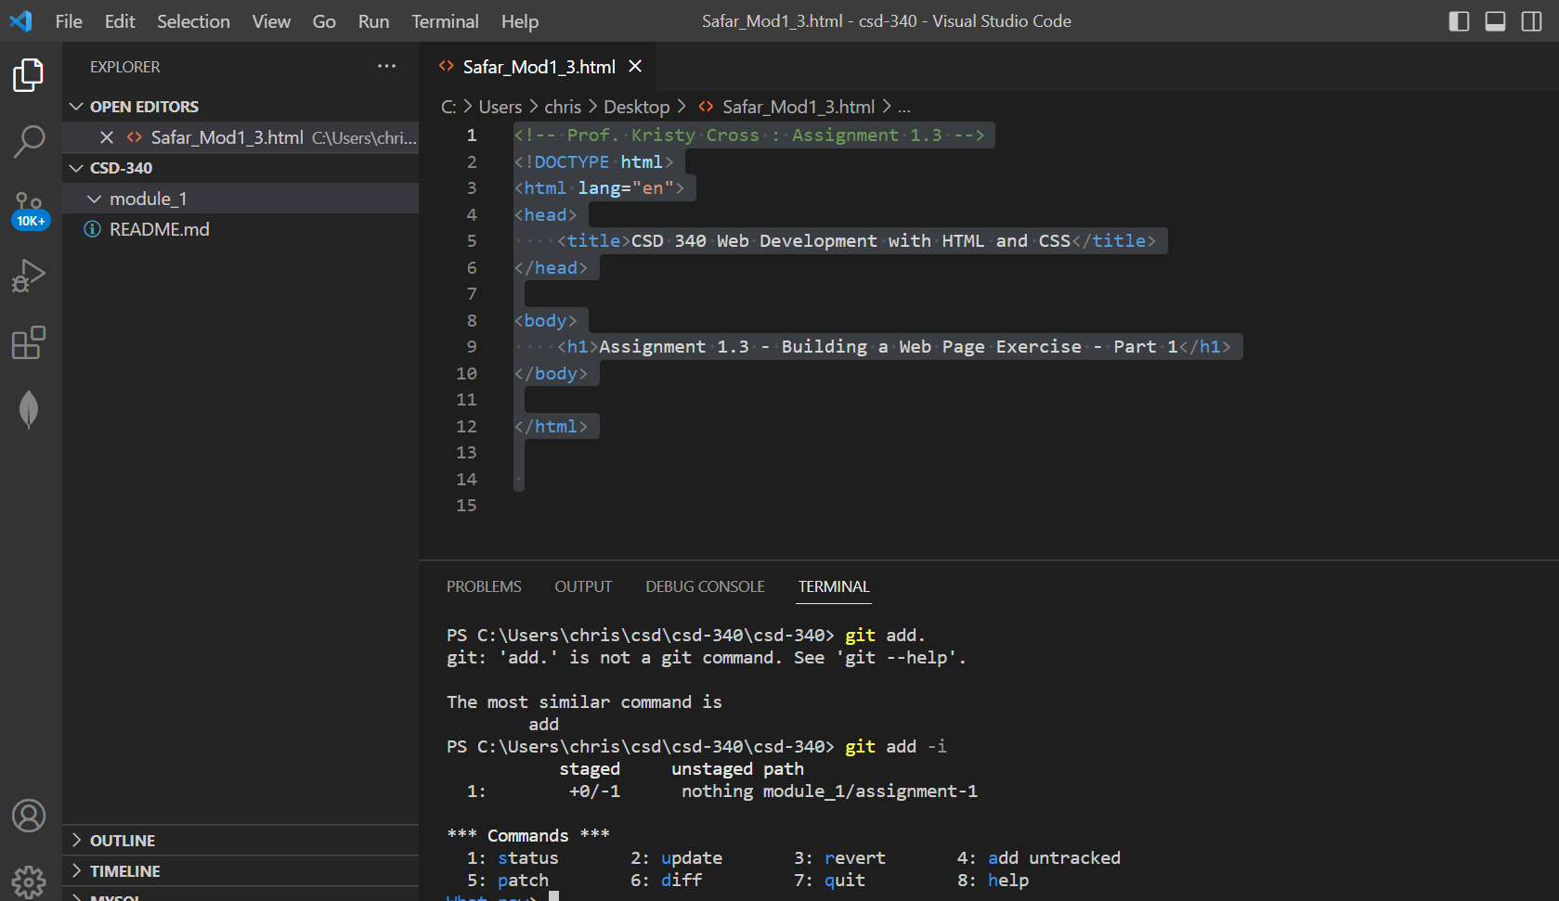

* Create a new HTML document in a text editor and name it <yourLastName_Mod1_3>.html and place it under the module-1 directory
* <!-- Prof. Kristy Cross : Assignment 1.3 -->
* <!DOCTYPE html>
* <html lang="en">
* <head>
* <title>CSD 340 Web Development with HTML and CSS</title>
* </head>
* <body>
* <h1>Assignment 1.3 - Building a Web Page Exercise - Part 1</h1>
* </body>
* </html>
* Using the below starter code, create a basic HTML page and add the code to your <yourLastName_Mod1_3>.html document



* Visit the World Wide Web Consortium (W3C) website and validate the markup you wrote using their HTML validator
  + Hint: select the “Validate by Direct Input” link and paste the markup you wrote into the “Validate by direct input” field
* Take a screenshot of the validators results (there should be one or more errors)
* Correct the identified errors
* Re-validate the HTML code
  + Hint: select the “Validate by Direct Input” link and paste the markup you updated into the “Validate by direct input” field
* Take a screenshot of the updated results (this time, there should be 0 errors)
* Add a single h1 element underneath the body element with the following text: “Assignment 2.2 – Building a Web Page Exercise, Part 1”
* Update the document's title to “CSD 340 Web Development with HTML and CSS’
  + Hint: update the text in the <title> element of the page <head>
* Re-validate the HTML code
* Take a screenshot of the updated results (this time, there should be 0 errors)

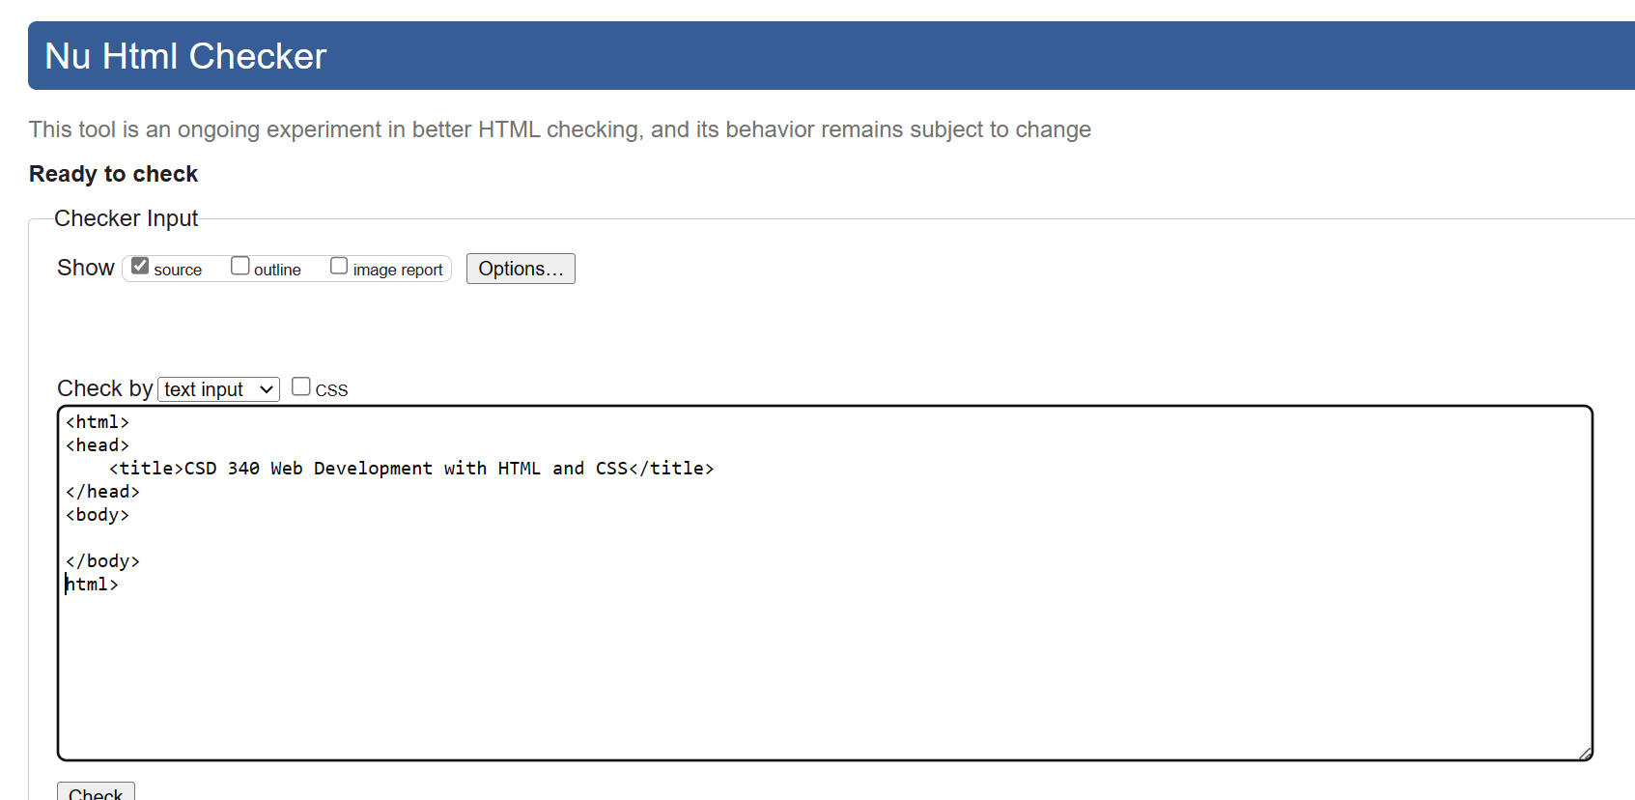

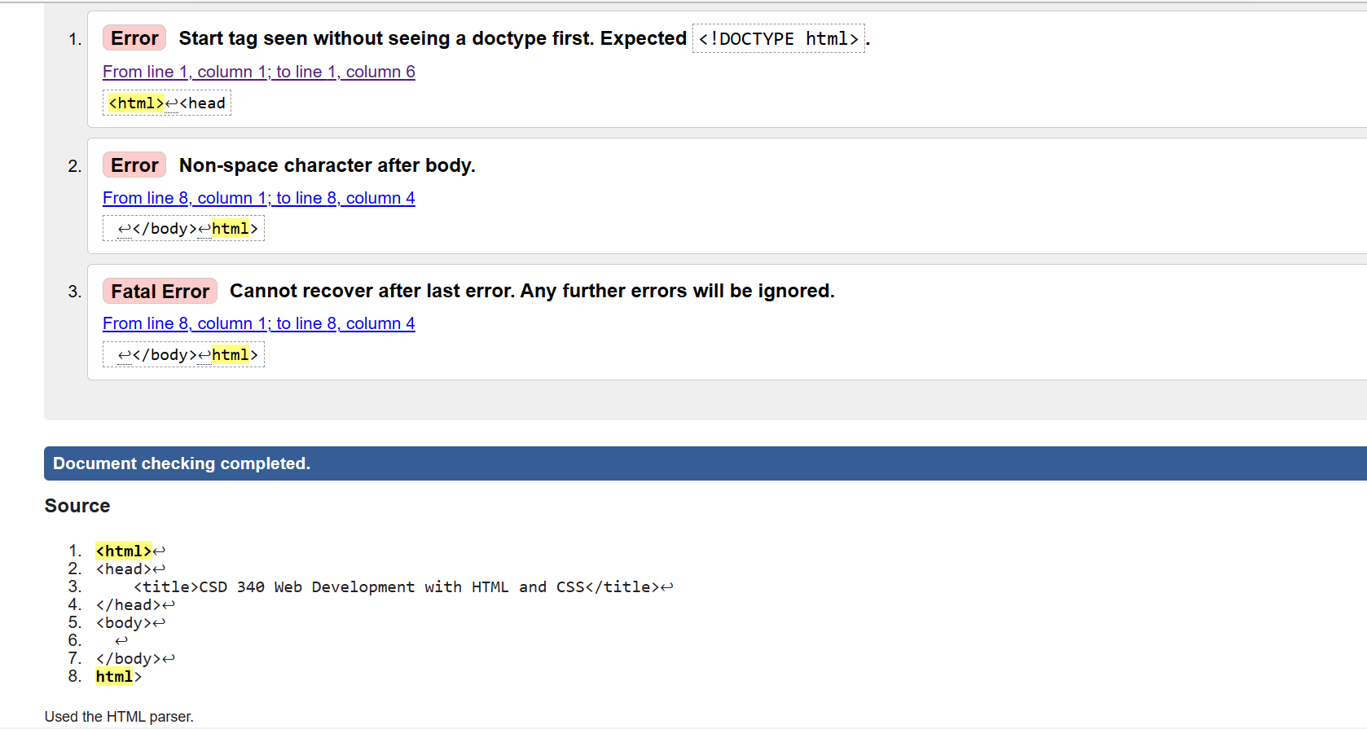

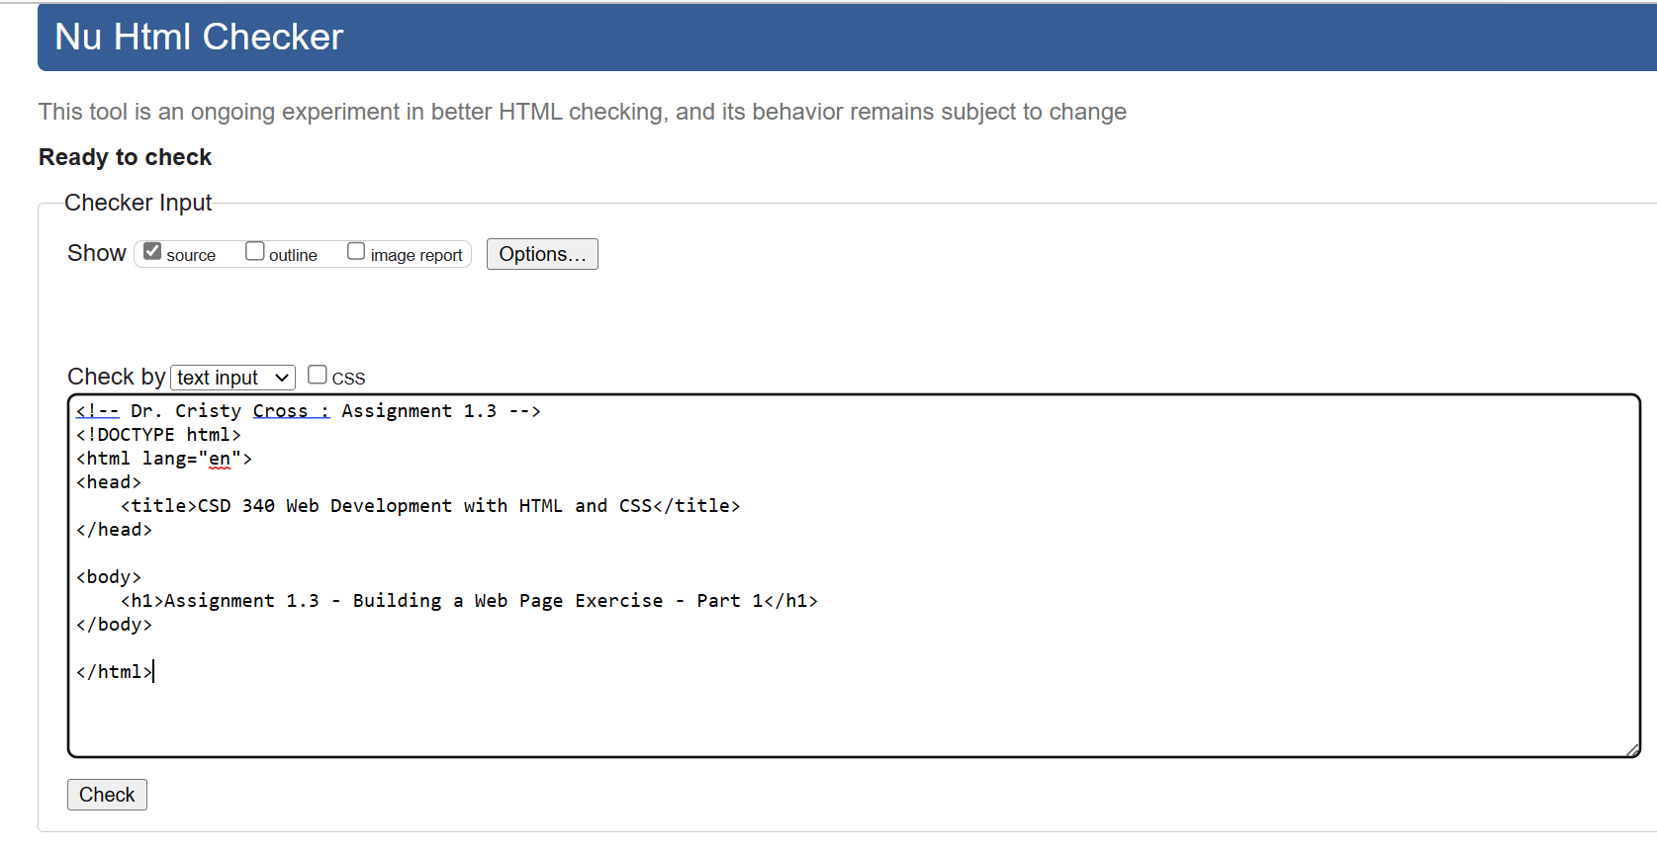

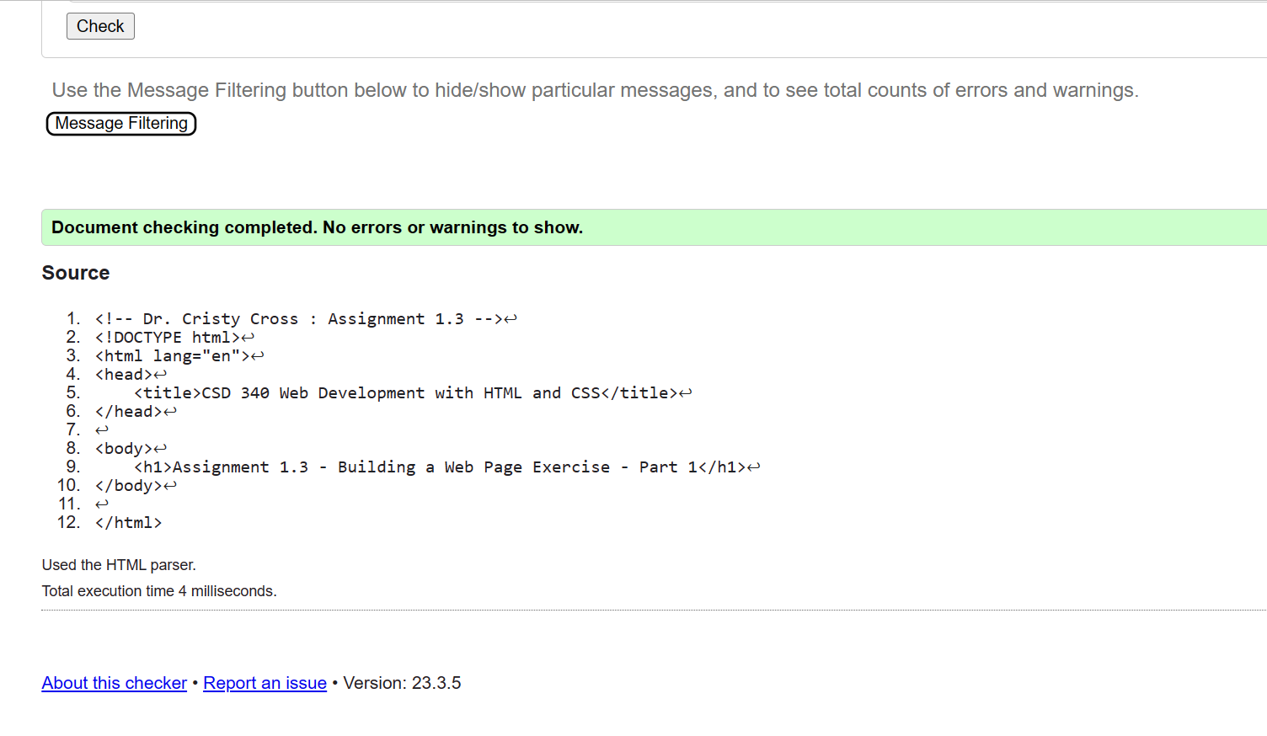

* Open the file in your computer's default browser and take a screenshot of the web page

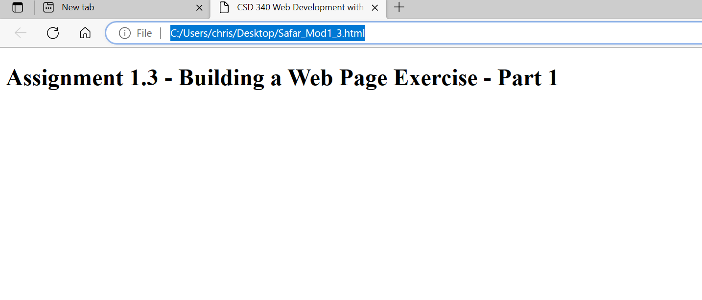

* Link to your GitHub repository.
* module-1 directory, packaged as a .zip file.
* <your-last-name>-<assignment-name>.docx (document containing the screenshots).